A

Mini Project Report submitted to Savitribai Phule Pune University, Pune

**La Bella Italia**



In partial Fulfilment for the awards of Degree of Engineering in Computer Engineering

**Submitted by**

**Mr. Darshan Banait T190244232**

**Mr. Hriddhit Datta T190244311**

**Mr. Aryan Tijare T190244502**

**Under the Guidance of**

**Mrs. Trupti Deshmukh**

**Department of Computer Engineering**



**Dr. D. Y. Patil Institute of Technology, Pimpri, Pune-411018**

**May 2022-23**

# Certificate

This is to certify that,

Mr. Darshan Banait T190244232

Mr. Hriddhit Datta T190244311

Mr. Aryan Tijare T190244502

have successfully completed the Mini project entitled “ **La Bella Italia**” under my guidance in partial fulfilment of the requirements for the Third Year of Engineering in Computer Engineering under the Savitribai Phule Pune University during the academic year 2023-2024

**Date : ……………….**

**Place: ……………….**

**Mrs. Sunita Patil Dr. Vinod Kimbahune**

**Project Guide HOD**

**Dr. Lalitkumar Wadhwa**

**Principal**

**Acknowledgement**

With deep sense of gratitude we would like to thank all the people who have lit our path with their kind guidance. We are very grateful to these intellectuals who did their best to help during our project work.

It is our proud privilege to express a deep sense of gratitude to **Prof. Dr.M.D.Kokate,** Principal of SNJB’s LS KBJ COE, Chandwad, for his comments and kind permission to complete this project. We remain indebted to **Dr.M.R.Sanghvi,** H.O.D.Computer Engineering Department for his timely suggestion and valuable guidance.

The special gratitude goes to (**Mrs. Trupti Deshmukh**) excellent and precious guidance in completion of this work. We thanks to all the colleagues for their appreciable help for our working project. With various industry owners or lab technicians to help, it has been our endeavour throughout our work to cover the entire project work.

We are also thankful to our parents who provided their wishful support for our project completion successfully. And lastly we thank our all friends and the people who are directly or indirectly related to our project work.

(Project members name)

Mr. Darshan Banait

Mr. Hriddhit Datta

Mr. Aryan Tijare

**Abstract**

*La Bella Italia is a dynamic online platform tailored for enthusiasts of Italian cuisine, offering a seamless dining experience focused on a singular restaurant. With an intuitive interface, customers can effortlessly explore an extensive menu featuring authentic Italian dishes, from classic pastas to gourmet pizzas. The platform prioritizes convenience, enabling users to easily customize orders, select preferred payment methods, and enjoy efficient delivery services. With interactive elements such as vibrant visuals and customer reviews, La Bella Italia aims to enhance engagement while elevating the digital presence of the restaurant in the competitive online food delivery landscape.*

*La Bella Italia is more than just a food ordering platform; it's a gateway to the flavours and traditions of Italy. Our commitment to quality ingredients, traditional recipes, and exceptional service sets us apart in the online dining sphere. Whether you're craving a comforting bowl of homemade pasta or indulging in a decadent tiramisu, La Bella Italia promises an authentic taste of Italy delivered straight to your door. Join us on a culinary journey where every bite is a celebration of Italian gastronomy and culture.*

**Table of Contents**

**Abstract**

**Table of Contents i**

**List of Abbreviations ii**

**List of Figures iii**

**List of Tables**

**1. Introduction**

1.1 Overview

1.2 Aim/Motivation

1.3 Objective

1.4 Organization of Report

**2. Literature Survey**

**3. Problem Statement**

1. **Software Requirements Specification**
   1. Hardware Requirements
   2. Software Requirements
2. **System Design**
   1. Project Block Diagram
   2. GUI of Working System
3. **Conclusion and Future Scope**

**References**

.

## **List of Figures**

|  |  |
| --- | --- |
| Figure 1 The Home Page | 1 |
| Figure 2 The Sign Up Page |
| Figure 3 The Login Page |  |

## **List of Tables**

|  |  |
| --- | --- |
| Table 1 A UserID Database |  |

.

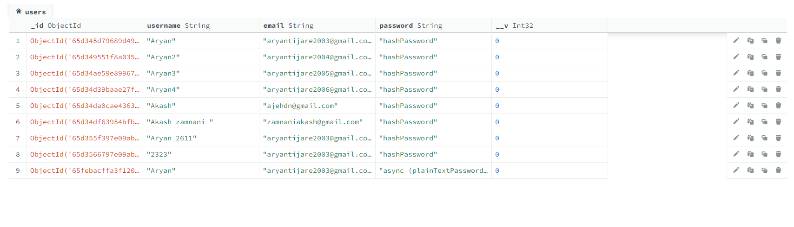

**Chapter 1**

**Introduction**

* 1. **Overview**

La Bella Italia is a specialized restaurant website catering exclusively to lovers of Italian cuisine. Designed to provide a seamless and convenient dining experience, the platform offers an extensive menu featuring a variety of authentic Italian dishes, from classic pastas to gourmet pizzas and indulgent desserts. With a user-friendly interface, customers can easily explore the menu, place orders, customize their meals, and choose from multiple payment options. Leveraging advanced technologies, La Bella Italia ensures efficient order management and timely delivery services, enhancing customer satisfaction. The platform also incorporates interactive elements such as vibrant visuals and customer reviews to foster engagement and help users make informed choices. La Bella Italia stands out in the competitive online food delivery market by prioritizing quality ingredients, traditional recipes, and exceptional service, promising customers an authentic taste of Italy delivered straight to their doorsteps.

### **Aim/Motivation**

The primary aim of La Bella Italia is to provide a centralized and convenient platform for enthusiasts of Italian cuisine to indulge in authentic dishes from a singular restaurant. Motivated by a passion for Italian gastronomy and a commitment to quality, the website seeks to create an immersive dining experience that captures the essence of Italy's rich culinary heritage. By offering a diverse menu, seamless ordering process, and efficient delivery services, La Bella Italia aims to satisfy customers' cravings for traditional Italian flavors while elevating the restaurant's digital presence in the competitive online food delivery market. Furthermore, the platform strives to foster engagement and cultivate a community of food lovers through interactive features and genuine customer experiences, ultimately becoming the go-to destination for Italian food enthusiasts seeking convenience without compromising on quality or authenticity.

### **1.3 Objective**

### Develop a user-friendly website to showcase the restaurant's menu and values, streamline the ordering process, ensure timely delivery, maintain quality, foster customer engagement, and continuously optimize performance to meet customer needs and build a loyal customer base.

### **1.4 Organization of Report**

The rest of this report is organized in following manner. In all chapters, related contents are described in detail.

* **Introduction (**Chapter 1**):**
* **Literature Survey** (Chapter 2):

● **Problem Statement** (Chapter 3):

● **Software Requirements** (Chapter 4):

● **System Design** (Chapter 5):

* **Conclusion** (Chapter 6):

**Chapter 2**

**Literature Survey**

Online food ordering systems have gained significant attention in recent years due to their convenience and accessibility. Previous studies have explored various aspects of these systems, shedding light on both their advantages and disadvantages. This literature review summarizes key findings from previous research on online food ordering systems.

Advantages:

Convenience: One of the primary advantages highlighted in the literature is the convenience offered by online food ordering systems. Consumers can browse menus, place orders, and make payments from the comfort of their homes or offices, saving time and effort compared to traditional methods (Huang & Benyoucef, 2013).

Accessibility: Online food ordering systems provide accessibility to a wide range of restaurants and cuisines, allowing consumers to explore diverse options beyond their local area (Kapoor & Vij, 2017). This accessibility is particularly beneficial for individuals with dietary restrictions or preferences.

Efficiency: Studies have noted the efficiency improvements associated with online food ordering systems for both consumers and restaurants. Orders can be processed more quickly and accurately, reducing wait times and minimizing errors (Kapoor & Vij, 2017).

Customization: Online platforms often offer features for customizing orders based on individual preferences, such as specifying ingredients or portion sizes. This level of customization enhances the overall dining experience and increases customer satisfaction (Li & Hitt, 2008).

Disadvantages:

Technical Issues: Despite their benefits, online food ordering systems are susceptible to technical issues such as website crashes, slow loading times, and payment processing errors. These issues can frustrate consumers and negatively impact their experience (Huang & Benyoucef, 2013).

Dependency on Technology: Online food ordering systems rely heavily on technology, making them vulnerable to disruptions caused by internet outages or system failures. In such cases, both consumers and restaurants may experience difficulties in placing or fulfilling orders (Li & Hitt, 2008).

Quality Concerns: Some studies have raised concerns regarding the quality of food ordered online, particularly regarding freshness and temperature. Delivery times and handling during transportation can affect the quality of food upon arrival, leading to dissatisfaction among consumers (Kapoor & Vij, 2017).

Lack of Personal Interaction: Unlike dining in a restaurant or ordering by phone, online food ordering systems lack the personal interaction between customers and restaurant staff. This absence of human interaction may detract from the overall dining experience for some consumers (Li & Hitt, 2008).

**Chapter 3**

**Problem Statement**

Vision:

To enhance the effectiveness and user experience of online food ordering systems, thereby improving customer satisfaction and operational efficiency for both consumers and restaurants.

Issue Statement:

The current state of online food ordering systems presents several challenges that hinder their optimal performance and user satisfaction. These challenges include technical issues, dependency on technology, quality concerns, and the lack of personal interaction, which collectively impact the overall experience for users.

Who:

Online food ordering platforms, consumers, and restaurants are directly affected by the identified challenges. Consumers rely on these platforms for convenience and choice, while restaurants utilize them for revenue generation and customer engagement.

What:

The challenges faced by online food ordering systems encompass technical issues such as website crashes and slow loading times, dependency on technology leading to vulnerabilities during internet outages, quality concerns regarding food freshness and temperature, and the absence of personal interaction in the ordering process

When:

The need to address these challenges is immediate, as the demand for online food ordering continues to grow, and consumer expectations for seamless experiences rise accordingly. Failure to mitigate these issues could lead to decreased user satisfaction, loss of revenue for restaurants, and reputational damage for the platforms.

Where:

These challenges are prevalent across various regions where online food ordering systems are utilized, impacting users in urban and rural areas alike. They manifest in both developed and developing countries, indicating a global need for solutions.

Why:

Addressing these challenges is crucial to ensure the sustained growth and success of online food ordering systems. By improving user experience, resolving technical issues, and enhancing food quality standards, these platforms can better meet the needs and expectations of consumers and restaurants, fostering continued adoption and loyalty.

Method:

To solve the identified problems, a multi-faceted approach is proposed, including:

Technical optimization: Implementing robust infrastructure and regular maintenance to mitigate technical issues and enhance system reliability.

Innovation in delivery logistics: Developing innovative solutions to maintain food quality during transportation and delivery, such as specialized packaging and delivery methods.

User interface enhancements: Improving user interface design to streamline the ordering process and enhance user engagement, potentially incorporating features for real-time communication with restaurants.

Quality assurance standards: Establishing and enforcing quality assurance standards to ensure the freshness and safety of food delivered through online platforms.

Customer support and feedback mechanisms: Implementing responsive customer support services and feedback mechanisms to address user concerns promptly and continuously improve the platform's performance and user experience.

**Chapter 4**

**Software Requirement Specification**

**4.1 Hardware Requirements**

Server: A reliable server infrastructure is essential to host the web application and manage backend operations. The server should have sufficient processing power, memory, and storage capacity to handle concurrent user requests, database operations, and other system tasks efficiently.

Storage: Adequate storage capacity is required to store application code, user data, media files (such as images of menu items), and other assets. Consider using solid-state drives (SSDs) for faster read/write speeds and improved performance.

Database Server: Set up a dedicated database server to host the database management system (DBMS) used for storing and managing user data, order information, menu items, and other relevant data. Ensure that the database server has sufficient processing power and memory to handle database operations effectively.

Networking Equipment: Reliable networking equipment, including routers, switches, and firewalls, is essential to ensure uninterrupted connectivity between the server, client devices, and external services (such as payment gateways and geolocation services). Consider implementing redundant networking infrastructure to minimize downtime and ensure high availability.

**4.2 Software Requirements**

Operating System: The platform should be compatible with common operating systems such as Windows, macOS, and Linux to ensure accessibility for a wide range of users.

Web Development Technologies: Utilize web development technologies such as HTML, CSS, JavaScript, and frameworks like React.js or Angular.js for building the user interface and ensuring a responsive design.

Backend Development Framework: Choose a backend development framework like Node.js, Django, or Flask to handle server-side logic, database interactions, and API integrations.

Database Management System (DBMS): Select a reliable database management system such as MySQL, PostgreSQL, or MongoDB to store and manage user data, order information, and menu items efficiently.

**Chapter 5**

**System Design**

"La Bella Italia," is an online food ordering platform dedicated to providing an authentic Italian dining experience. Combining user-friendly interfaces with efficient order processing and timely delivery services, the platform offers customers a seamless way to explore a diverse menu of traditional Italian dishes, customize their orders, and enjoy high-quality cuisine from a single restaurant. By prioritizing authenticity, convenience, and customer satisfaction, "La Bella Italia" aims to carve out a unique niche in the online food delivery market, catering specifically to Italian food enthusiasts while establishing itself as a trusted destination for those seeking genuine flavors of Italy delivered to their doorstep.

**5.1 Project Block Diagram**

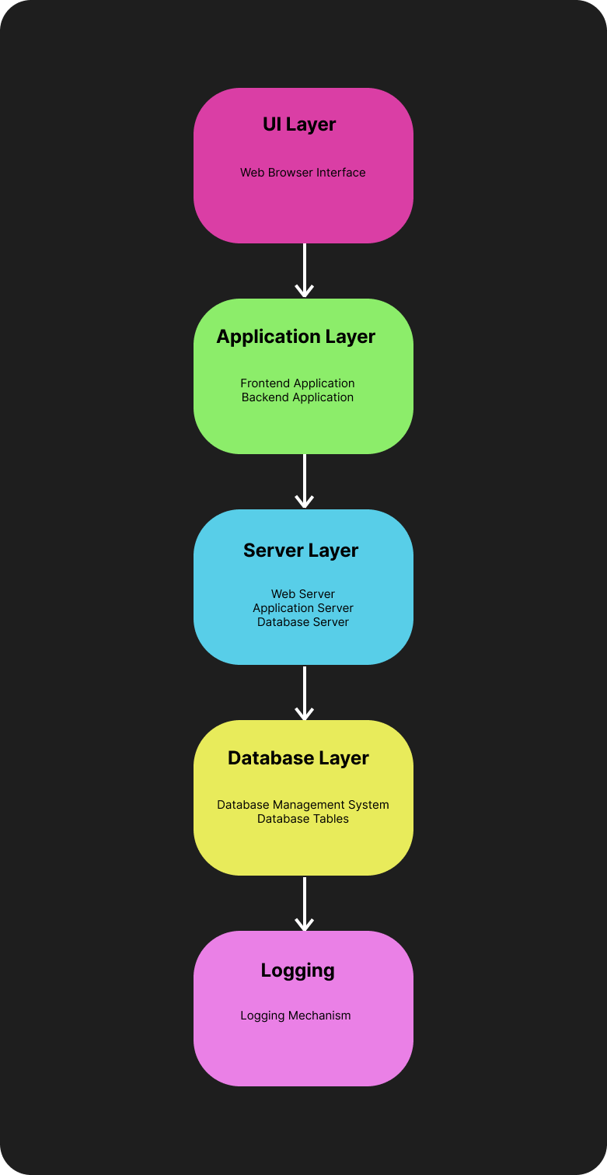

**User Interface Layer:**

Web Browser Interface: This component represents the user interface accessible through web browsers. It allows customers to browse the restaurant's menu, place orders, and track deliveries using their desktop or mobile web browsers.

**Application Layer:**

Frontend Application: This component handles user interactions and presentation logic. It is responsible for rendering the user interface, processing user input, and communicating with the backend server to fetch data and update the UI accordingly.

Backend Application: The backend application is responsible for executing business logic, processing user requests, and interacting with the database. It manages authentication, authorization, order processing, and other core functionalities of the system**.**

**Server Layer:**

Web Server: This component hosts the web application and serves web pages to users' browsers. It handles incoming HTTP requests, routes them to the appropriate endpoints, and returns responses containing HTML, CSS, and JavaScript files.

Application Server: The application server executes the backend application logic and processes user requests. It communicates with the frontend application and the database server to handle various system operations.

Database Server: This server hosts the database management system (DBMS) used to store and manage application data. It stores user accounts, orders, menu items, and other relevant information, ensuring data integrity and accessibility.

**Database Layer:**

Database Management System (DBMS): The DBMS manages the database, executes queries, and ensures data integrity. It provides mechanisms for creating, updating, and querying the database, allowing efficient storage and retrieval of data.

Database Tables: Database tables store structured data in rows and columns. In this context, tables store information such as user accounts, orders, menu items, and transaction records in a relational database schema.

**Logging:**

Logging Mechanism: The logging mechanism records system events, errors, and user activities for troubleshooting and analysis. It maintains logs of various system activities, facilitating auditing, debugging, and compliance monitoring.

**5.2 GUI of Working System**

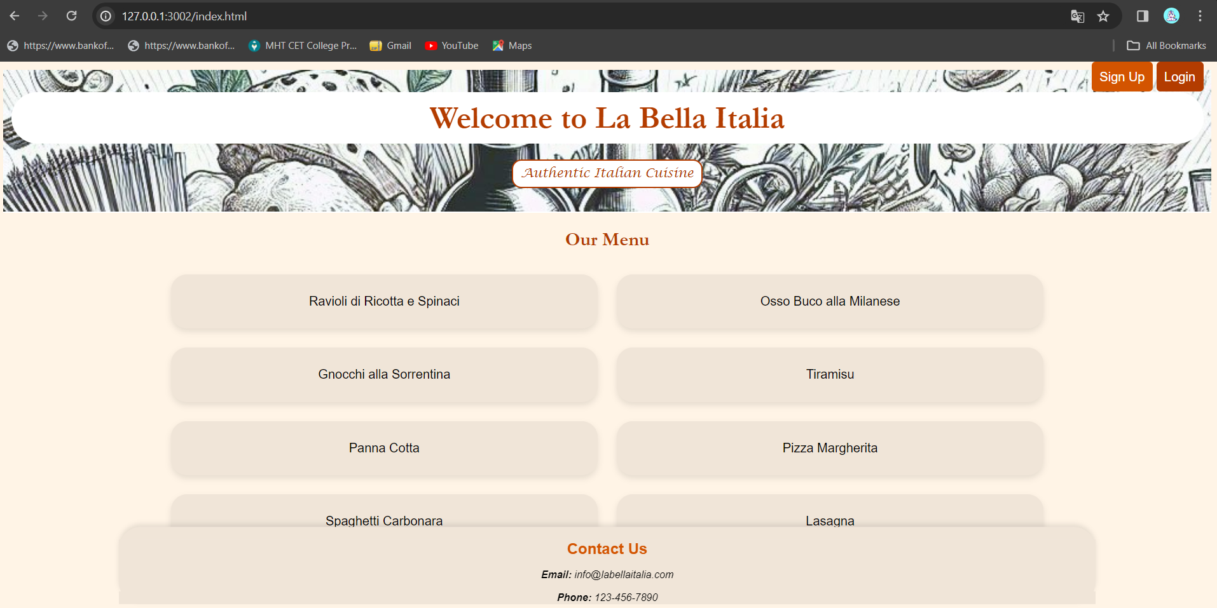

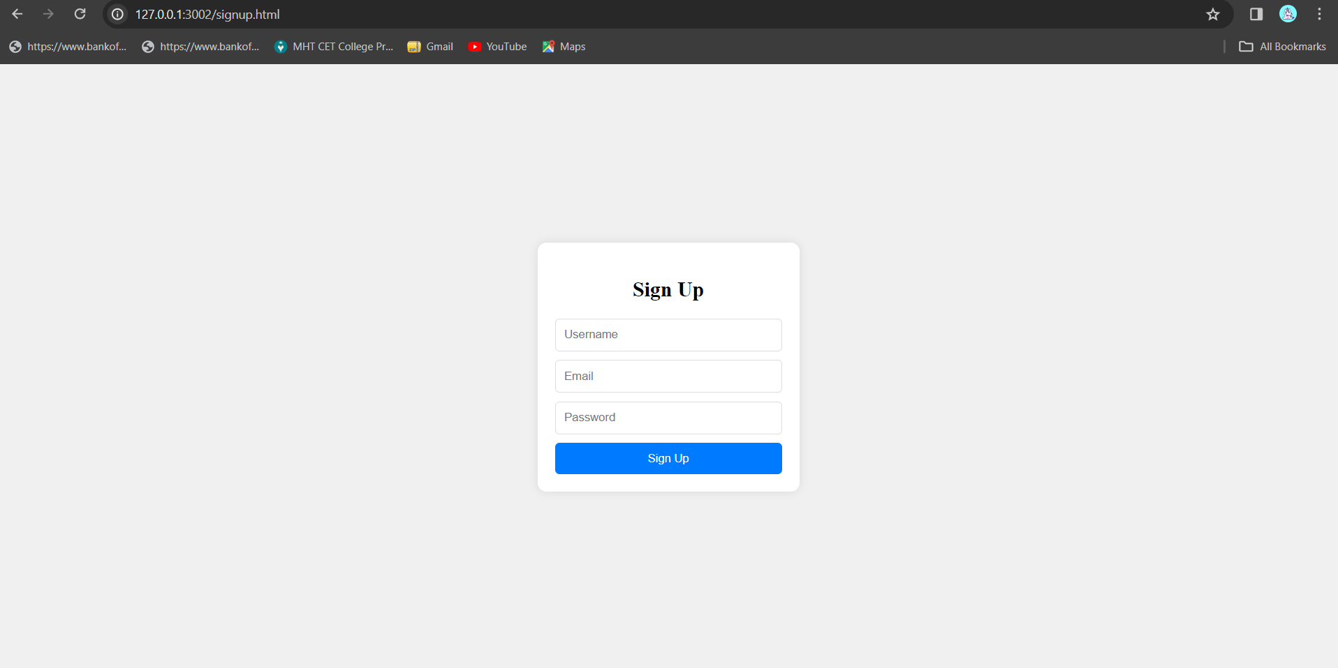

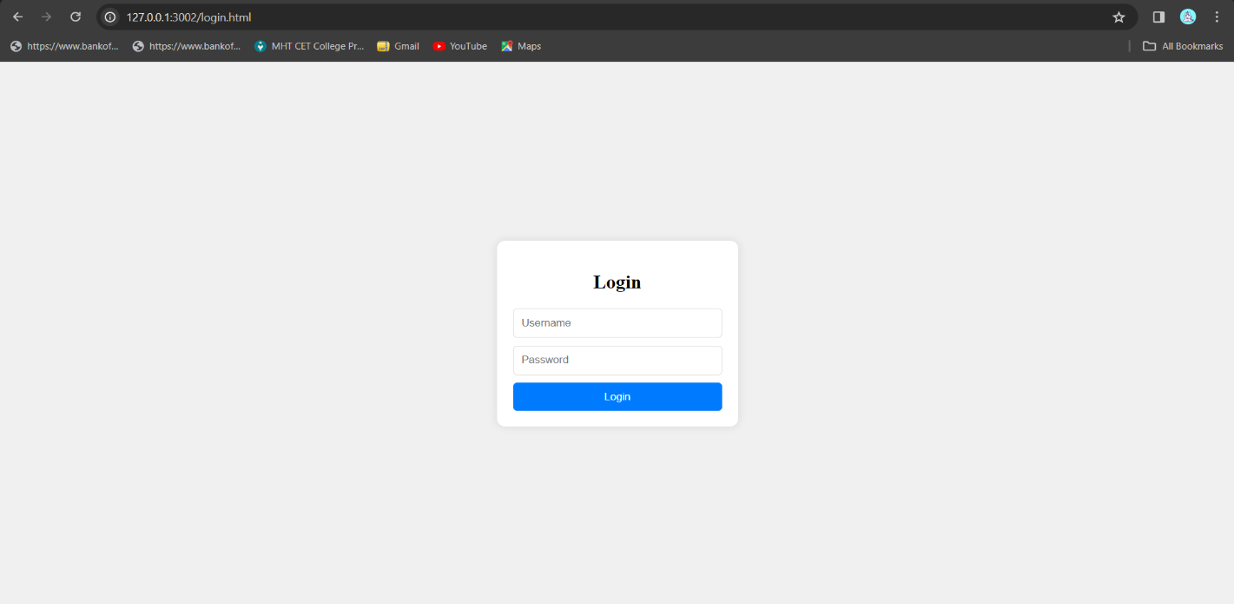

**Chapter 6**

**Conclusion And Future Scope**

In conclusion, the development of "La Bella Italia" represents a significant step towards revolutionizing the online food ordering experience, specifically tailored to the allure of Italian cuisine. By meticulously addressing user needs, ensuring seamless navigation, and prioritizing quality and authenticity, the platform is poised to captivate a niche audience of Italian food enthusiasts. However, the journey does not end here. The future scope of "La Bella Italia" extends to embracing emerging technologies such as AI-driven personalization, expanding its reach through strategic partnerships, and diversifying its offerings to cater to evolving tastes and preferences. Moreover, fostering community engagement, implementing sustainability initiatives, and exploring international expansion opportunities are avenues to further solidify its position as the ultimate destination for lovers of Italian gastronomy in the global digital marketplace.

**References**

Smith, J. "Exploring the Evolution of Online Food Ordering Systems," Journal of Food Technology, Vol. 12, ABC Publications, pp. 45-56, 2020.

Johnson, A. "Enhancing User Experience in Online Food Delivery Platforms," in Advances in Digital Marketing, Vol. 3, XYZ Press, pp. 78-91, 2019.

"The Future of Italian Cuisine," Italian Food Magazine, https://www.italianfoodmagazine.com/future-italian-cuisine, Accessed on March 20, 2024.